**PASTEL**

**ROM-COM GAME**

**A bittersweet romantic comedy based on manga: PASTEL**



**MARKETING**

**Genre**

Romantic Comedy (ROM-COM),Adventure game.

**Category**

Dating Simulation, Adventure

**Similar Titles**

My Sweet Roomies, Persona

**Setting**

Based on a small town named Onomichi, also some parts of Tokyo.

**High Concept**

Pastel ROM-COM is a dating simulation game reflecting the life of some high school students living in a small town named Onomichi where lives the game protagonist name TADANO MUGI who is simple looking, kind-hearted boy and unknowingly a gigolo, who is unintentionally doing all those things that affects the feeling of girls he knows greatly and they end up falling for our kind hearted guy.

Pastel would offer great interaction to the player with different kind of girls among which the player could choose to be with his favorite girl and follow the appropriate path to become her lover.

**PLOT**

The story plot consists of three main acts where each act refers to each year in the high school.

1. First year - Started of being living together
2. Second year – Started of Being Responsible
3. Third year - Starting the Journey’s End

Same as the story of the Manga title Pastel, the game itself is divided into 3 acts and the player has to overcome each act in order to get himself promoted to the next year. For a little realistic touch, the player as a high-school student has to give Final exams in order to get a passing grade or its GAME OVER!!!

But Don’t Worry, not that you will giving the exams same as High-School level, they will just some easy English and easy Arithmetical problems.

With the Finale of the game the special ending with each girl would unlock with whom the player (Tadano Mugi) decides to spend his life with.

**ACT 1 – First Year**

Tadano Mugi has just broken up with his Girlfriend who was moving to Tokyo, and so, to overcome his depression, he decided to work part-time at his cousin’s aunt beach restaurant. One fine day, he saw a beautiful girl with a nice figure changing into her swimsuit at the restaurant’s backside, startled he drops the beer crate on his foot. The girl sees him and asks for the payment of that unexpected peep from our hero, MUGI. It was love at first sight for MUGI. The name of the girl is Tsukisaki YUU. He later went on a Blind date with her too, LUCKY GUY!

At the end of the trip as MUGI-kun returns home, he hears his father bathing and so he barges in the washroom, but what he finds is extremely unexpected and he keeps standing there astounded to find Yuu bathing in his washroom and he is hit hardly with the bucket.

Later he comes to know that Yuu and Tsukasa (Yuu’s sister) have lost their father and so Mugi’s father who was a colleague offered both the girls to live at their home in Onomichi and so the life of MUGI with his crush Yuu starts under the same roof.

**ACT 2 – Second Year**

As the story proceeds further Mugi comes to know about Yuu’s mother who later comes to pick them up to take them to her house and so the second year of Mugi’s High-School goes without the presence of Yuu. Now it is up to the player that he wants to move on and increase his friendship with other girl or if he wants to wait for Yuu and so the player would obtain many opportunities to meet many girls during the time.

**ACT 3 – Third Year**

After a year of Yuu’s absence many things change but not our kind-hearted protagonist, TADANO MUGI.

At the start of the third year of high-school Yuu comes back to Onomichi to complete her high school at the town and Tsukasa along with their mother and step-father moves to America.

Many times, Tsukasa would come to visit both of them and later she also brings a surprise guest named Pepper.

**Competitive Analysis**

* Exciting, roleplaying in a beautiful place.
* AI that acts up according to the player’s advancements.
* Small mini games that the player can enjoy anytime.
* Emphasis on character development ensure that every character is unique.
* Ensures that each player’s experience is different
* DUAL Game modes which would also enable the player to even play through the story of TOSHIHIKO KOBAYASHI sensei.
* Clear goals, constant rewards, varied interactions.
* Interaction with dozens of unique non-player characters. A simple, elegant conversation system results in non-player characters you really care about.
* Situations that evolve over time, influenced by player action.

**GAMEPLAY OVERVIEW**

What follows are the high-level descriptions of key design philosophies that will drive game system design and development. Detailed outlines of specific game systems will be added to this document as appendixes as they become available.

**Dating Simulation**

This game purely is a dating simulation game where the player plays as the male Main Character known as Tadano Mugi.

Here the player will come across various different (sometimes confusing) situations as he keeps meeting different girls in the game.

Well, not everyone’s favorite could be same, and that thing has been taken care of as the game consists of girls of different characters having different feelings like, quick to be jealous, spectacled, clumsy, always angry or even dumb, every girl is different and so it completely depends on the players which girl to choose as his (Tadano Mugi) own partner.

The flow of the game is multidirectional i.e. it completely depends on the player how he moves forward in the game and which direction the game has to move to.

The game also consists of various twists and turns which would make the player confused, well, its not easy to know what is going on in the girl’s mind without knowing enough about her and so player has to make sure that he and his favorite girl are on great terms with each other. The Game consists of 5 stages which the player has to cross in order to win his girl’s heart :

STRANGER >> ACQUAINTANCE >> FRIEND >> BEST-FRIEND >> LOVER

**INTERESTING INTERACTIONS**

This part consists of the brief description of the 5 stages applicable to each girl in the which the player has to cross to win his favorite girl’s love.

1. **STRANGER**: The player has just met a girl in the game and so they both are completely strangers to each other. In this situation there is not much the player can do. All he can do for now is ask the stranger about something or someone, or get some directions. Player can also ask something about her, like, her name and like this the player can make his presence known to the girl.
2. **ACQUAINTANCE**: An acquaintance is someone who is known and it’s not impossible for an acquaintance to become a FRIEND if there is descent conversation going on, and so, the player can unlock certain dialogues being an acquaintance like, he can compliment the girl’s looks and increase his points.
3. **FRIEND**: “A friend in need is a friend indeed”, a quote which is strictly required to be followed if the player wants to prove himself being a friend worthy of the girl’s trust. He should be someone who the girl can seek for suggestions and help, who is also present during the fun times. TAKE CARE!! The path to love is not far.
4. **BEST FRIEND**: ‘Things are never quite as scary when you’ve got a best friend’. A bestie knows all of his friend’s secrets and so it’s the best stage where the player could know everything about his favorite girl and so he is the closest to being a lover to his female best-friend. Though the stage of best-friend looks easy-going but it is not, as this is the most crucial stage where the player has to take each step carefully moving forward because if the player is even a tad-bit incautious, even the friendly relation he has with the girl could crumble.
5. **LOVERS**: The final stage, where the player’s confession has been accepted by his favorite girl and they have become LOVERS, but as it is necessary, the player should be cautious and be attentive to his girl. He should prove himself to be a great boyfriend who is always there to support his girlfriend.

Now, the most interesting part of the game is that the player can actually go out with more than one girl, BUT !!! he has to be very careful of his girlfriends not meeting each other as this could end Mugi-kun in a hospital…HaHa!!



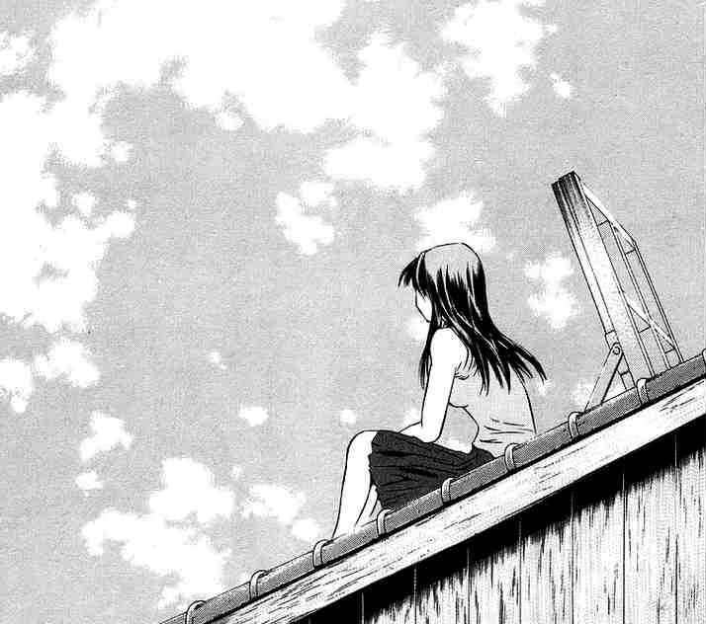

**Game Progression**

The game starts with an opening song consisting of slides with the characters art, the screen would also contain the moving text introducing the beginning of the story: “*Tadano Mugi, a first-year high school student was recently dumped because of his girlfriend moving to Tokyo with her family. After being dumped Mugi lost all his self confidence and so to overcome his sadness, he goes to the summer house of his cousin Kazuki’s aunt where he works part time to indulge himself and keep of the thoughts of his ex-girlfriend………. One day, as he was doing an errand, he saw someone!!!!!*”

And so, the game starts with the encounter of Mugi and that *someone.*

The game would further move forward with **various twists and turn events.**

It depends on the player how good he wants to have his relationship with others. With game progression depending upon the player, the ending of the game too depends on the player’s moves as well.

Also, like a high school student, the player too will have to give exams of the end semester and move on to the next chapter of the game. The player will have two chances of passing his exams i.e. the player will have a chance to give makeup exams as well.

**Mission/Challenges**

Though the game does not consist of specific missions but in order to help the player, a **DIARY** is added in players inventory where all the promises and upcoming dates of the player would automatically enter as he makes them.

And so, the **DIARY** can be considered as an objective bar which the player has to fulfill in order to maintain good relations with his acquaintances.

The **DIARY** is shown after the completion of each objective with the completed objectives ~~SCRATCHED OUT~~.

**DIARY** can also be accessed anytime from the inventory.

**Game Flow**

First Splash screen – Publisher

Cinematic

Second Splash screen – Developer

Cinematic

Introductory Cinematic: The opening song and introductory Text.

Main Menu: A screen with Live 3D movie background showing places and people you will encounter throughout the game.

Options

* New Game: Clicking would take you to a screen with 2 Game modes:

1. FREEPLAY: enable player to move in the game according to his own path and have his own different game experience.
2. Story Mode: enables the player to move according to the original story written by Toshihiro Kobayashi sensei.

* Load Saved Game: enable the player to continue his previous game.
* Settings: Takes player to the settings window where player can run the game according to his system’s specifications.
* Another Time: exits the game.

**GRAPHICS**

**Landscape**

As we already know, this is a dating simulation game and so beautiful landscapes is the ISP of this game. Beautiful sceneries and stunning artwork are what would make the game appealing to the player.

Besides the faces of the story characters, many other animated faces could be noticed. The graphics of the game would be semi-3D which would give the player both the 3D experience and also the experience where he would feel nearest to the 2D characters. Great Graphics and great details to bring out the realness of the surroundings.

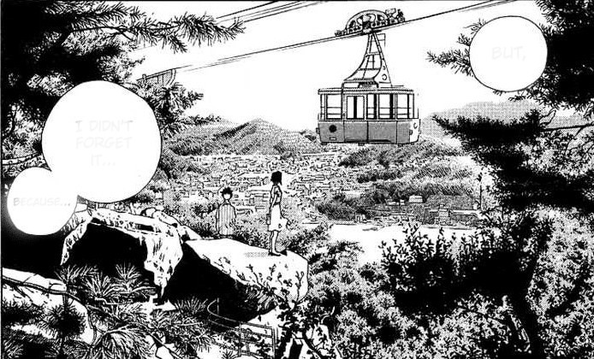

**Reduced Detail**

A reduced detail mode will also be included for PCs which are not fast enough to display the whole perspective view. In this mode the graphics would be set to SMOOTH settings.

**Screen Display**

Energy bar is will be displayed at the top left corner of the screen. Below it, the player can find the NOTEBOOK icon, which opens the list of current objectives the payer has to do.

At the left of the screen will be a heart shaped icon, clicking which would display player’s progress with each girl in percentage.

There would be another icon for inventory on the bottom right of the screen, where the player can store all his hard-earned money and the gifts he bought with that.

**Popups**

Miniature popups windows could appear occasionally to show animations of what is happening, e.g. confessions, cliché events and the kissing too.

**Weather**

As the game covers all the three years of the high school, all seasons could be experienced by the player. Also, with different seasons, comes different events including CHRISTMAS, Autumn Festival, Annual FEST, New Year and many more special events.

* Summer: sunrays would fall on the main camera depicting as if they are falling on the player’s eyes.
* Rainy: With a great deal of detailing in the rain, the raindrops would also appear to fall on the screen.
* Autumn: Animation of falling leaves have been added to many events. The time these leaves fall during park trips add to the scene’s beauty.
* Winters: Snowfall is there which will appear to pile up with time in order to make the whole place white and beautiful. Winters add to many additional events of player making snowman and small snow ball fights.

NOTE: All the above animations could be toggled on/off according to the players convenience.

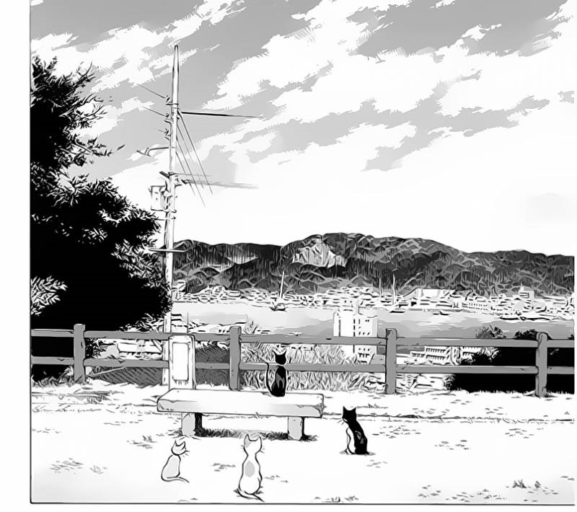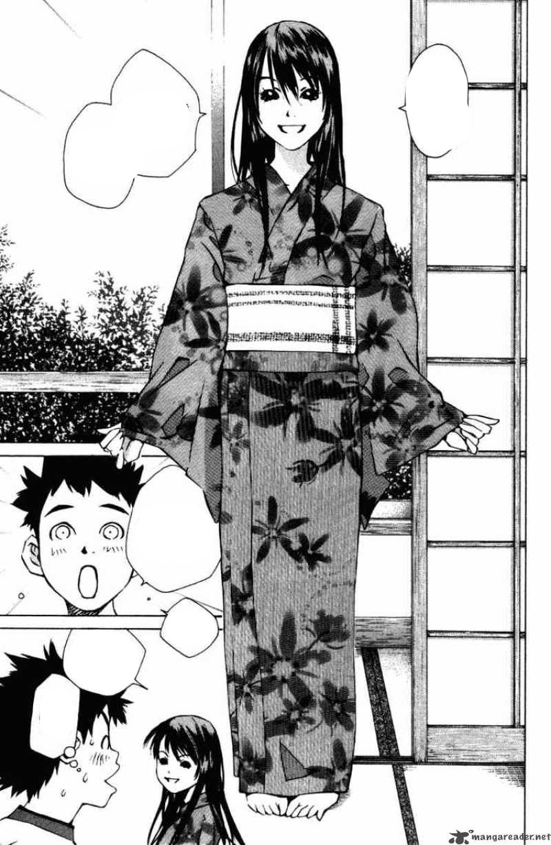

**Target System**

PASTEL rom com will be produced for the following platforms: PC Windows 8,10, Sony PlayStation 4, XBOX one

This document is primarily concerned with the PC version.

**Windows**

The 64-bit Windows version will require a minimum:

4 GB RAM

5 GB Hard-disk space

Nvidia GeForce GT-710

**Where to Get?**

The game can be bought from the nearest Game stores and can also be downloaded from STEAM store.

**Developer TOOLS**

The game is developed using the latest Unity 5.X version.

The scripts game consists are made using Mono-DEVELOP with C#.